
Request for Information from Seller
Please complete the following information and return to our office with a copy of your ID as soon as possible. It may be faxed to 301.560.5393 or emailed to: info@pinnaclesettlements.com

Our File No.: 21-0571 Property Address: 20401 Bloomingville Court, Germantown, MD 20876

NAME: Yiming Qiu
Email Address:____ymqui@yahoo.com___________ Social Security#:____219-47-3415__________
Phone Numbers: WK______________________Cell______________________HM_(301)972-3732_____

NAME: Weifen Mao
Email Address:__maoweifen@gmail.com_____ Social Security#:_____215-87-4583______
Phone Numbers: WK______________________Cell (301)580-8998___HM________________________

FORWARDING ADDRESS AFTER SETTLEMENT:
212 Currier Dr, Rockville, MD 20850_________________________________________

Will all sellers be attending settlement? _Yes__ If not, please contact our office to make arrangements.
Are All Sellers a Maryland Resident? __Yes___ If not, please contact our office for further instructions.
Are all Sellers US Citizens or Residents? _Yes__ If not, please contact our office for further instructions.
Are any sellers involved in current Bankruptcy proceedings? ___No______
How would you like to receive proceeds from Sale? Check ______Wire_X__(provide voided check/acct info at closing)

Mortgage Information:
First Mortgage Second Mortgage
Name of Lender: __M&T Bank _______ Name of Lender: __________________________
Account Number: __0014417356____________ Account Number: __________________________
Phone: __(800)724-2224_____ ____ Phone: __________________________
Additional liens or payoffs: _The mortgage has been paid off._____ ____________________________________

Homeowners/Condo Association Dues: Yes [ X ] No [ ]
Company/Contact: _Summit Mamagement Service________
Account Number: _CW19269___ ______________
Phone: _(301)495-0146__________ ________
Fax/Email: _(301)933-2625_____________________
IS THERE A 2nd HOA or Condo (if yes provide Contact info)_______No______________________

Ground Rent/Lease: Yes [ ] No [ X] Yr./Mo. Front Foot / Water – Sewer facility Charge:
Yes [ ] No [ x ]
Company/Contact: ____________________________ Company/Contact: _______________________________
Address: ____________________________ Address: _______________________________
Phone: ____________________________ Phone: _______________________________
Fax/Email: ____________________________ Fax/Email: _______________________________

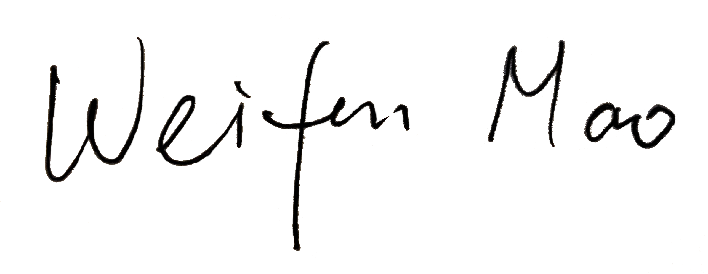
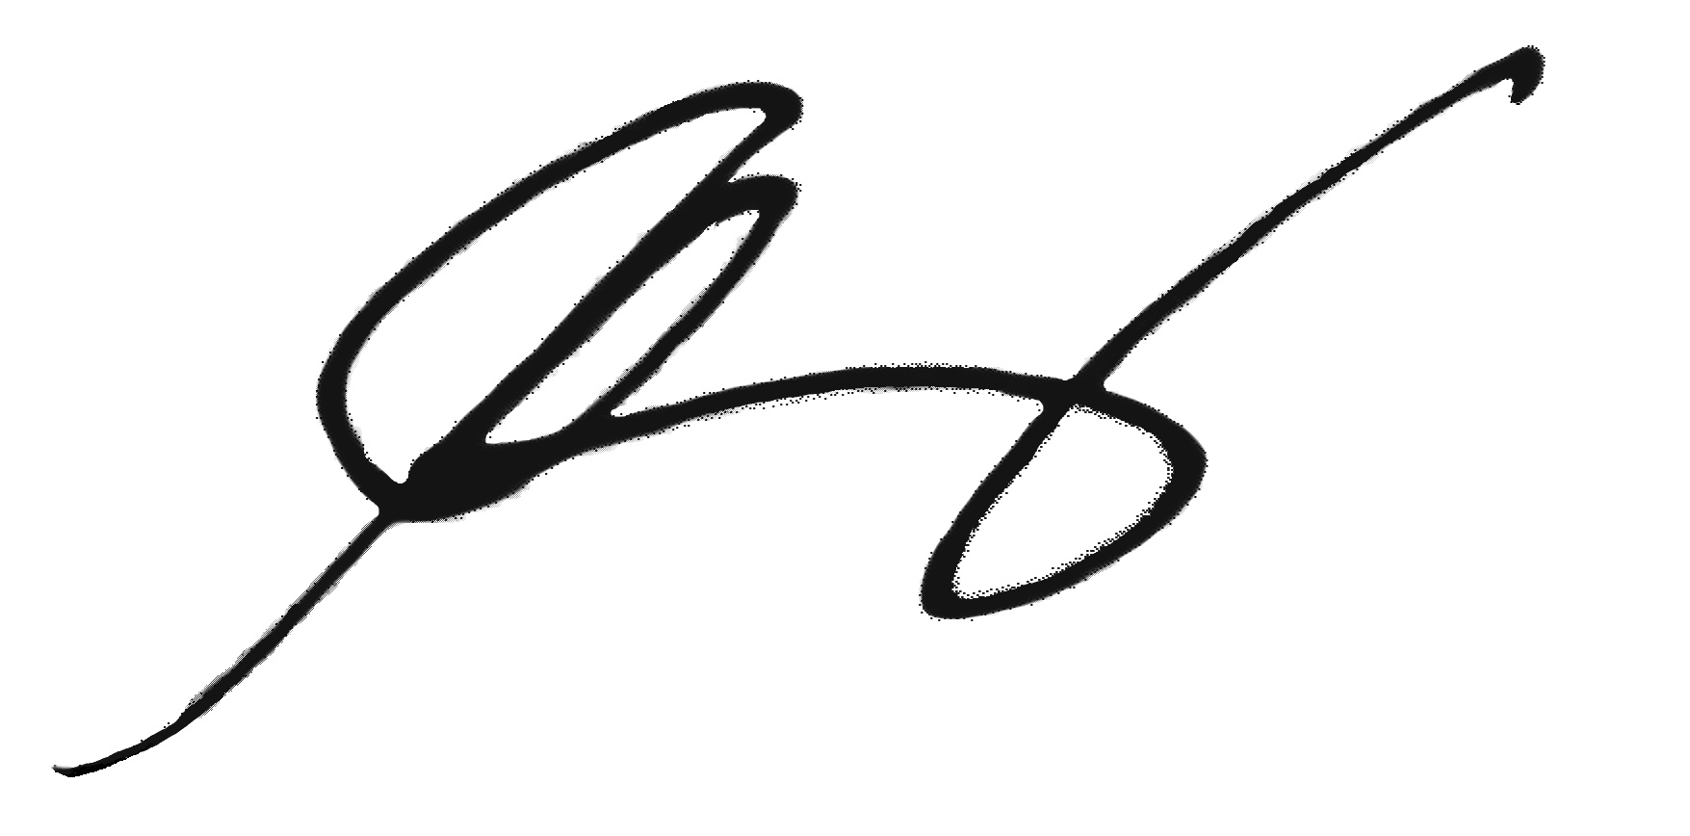
We hereby give our consent for the release of any and all payoff figures regarding liens against the referenced property.

______________________________ 07/20/21 _____________________ _ 07/20/21
Signature Date Signature Date

